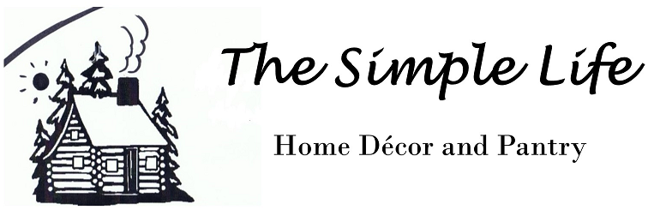
Hand crafted gifts, inspired by nature, made with only repurposed, recycled or naturally sourced materials.
Pantry Items and Price List

Borscht $15 ~NEW~
Cabbage Roll Soup $15 ~Best Seller~
Fall Harvest Soup $15 (squash, pumpkin, sweet potato and apple)
French Wild Leek Soup $10 ~NEW~
French Onion Soup $10
Garden Vegetable Dip Mix $10
Garlic Seasoning $5 (made with 3 kinds of garlic, garlic scapes and wild leek)
Italian Seasoning and Dressing $5
Old Bay Seasoning Spice $5
Onion and Wild Leek Dip $10
Rhubarb Pork Rub $5 ~NEW~
Smith’s Caesar Rimmer $5
Spinach Dip $10
Stuffing Mix $10
Wild Leek Powder $3

Blended Fruit and Herb Tisane (Tea) $1 each or 3 for $2

Basil and Strawberry
Cranberry Spice (cloves nutmeg and cinnamon)
Rosemary, Lavender and Lime
Sage and Green Apple
Thyme and Raspberry

